Code :  
  
#include <stdio.h>

#include <string.h>

typedef struct StudentDeatils{

char Name [30] ;

int CetRank;

char Branch [18];

}Student;

void Input (Student Student[] ,int Size ) {

for (int i = 0 ; i < Size ;i++) {

printf("Enter The Deatils Of Student %d \n" ,i + 1) ;

printf("Enter The Name Of Student :");

scanf("%254s",Student[i].Name);

printf("Enter The CET RANK Of Student :");

scanf("%d",&Student[i].CetRank) ;

printf("Enter The Branch Of Student :");

scanf("%245s",Student[i].Branch) ;

}

}

void SegergateBranch(char TargetBranch [],int Size ,Student ArrayOfStudents []) {

for (int i = 0 ;i < Size ;i++) {

if (strcasecmp(ArrayOfStudents[i].Branch,TargetBranch) == 0) {

printf("Student From The :%s \n",TargetBranch,"Are :");

printf("Branch:%s \n",ArrayOfStudents[i].Branch) ;

printf("Name: %s \n",ArrayOfStudents[i].Name) ;

printf("CET RANK :%d \n",ArrayOfStudents[i].CetRank) ;

}

}

}

int main (){

int Size ;

printf("Enter The Number Of Student :") ;

scanf("%d",&Size);

Student ArrayOfStudents [Size] ;

Input(ArrayOfStudents ,Size) ;

char TargetBranch [18];

printf("Enter The Branch Do You Want See To Students From :");

scanf("%s",TargetBranch);

SegergateBranch(TargetBranch,Size,ArrayOfStudents);

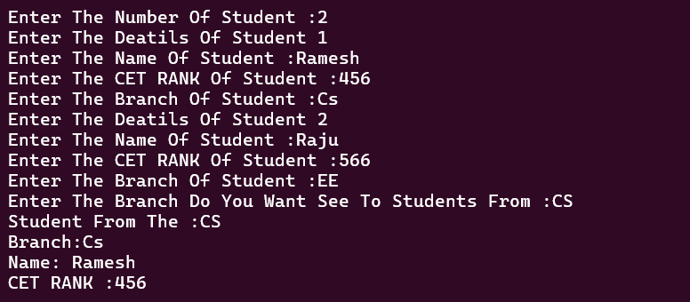}  
  
  
Output :